Ideation Phase Empathize & Discover

|  |  |
| --- | --- |
| Date | 22nd JUNE 2025 |
| Team ID | LTVIP2025TMID59454 |
| Project Name | LearnHub: Your Center for Skill Enhancement |
| Maximum Marks | 4 Marks |

**Empathy Map Canvas:**

# USER PERSONA:

**Name:** Priya Sharma

**Age:** 21

**Background:** Final-year engineering student

**Goal:** To improve her technical and soft skills and become job-ready.

**Frustration:** She feels unprepared for interviews despite having good academic scores.

# SAYS

* “I wish my college provided more practical learning.”
* “I want to get placed in a good company, but I don’t know what skills I’m missing.”
* “I need certifications that are actually valued by recruiters.”
* “There’s too much information online — I don’t know what to focus on.”

# THINKS

* “Will this platform actually help me get a job?”
* “Others seem to be doing better because they’re taking extra courses — am I behind?”
* “I hope this isn’t another boring, theoretical program.”
* “I need to make good use of my final year.”

# DOES

* Attends online and offline workshops
* Searches YouTube/Google for free courses
* Asks peers for course or platform recommendations
* Updates her resume regularly, but with little guidance

# PAINS

* Lack of guidance on what skills are most important
* Confusion due to too many platforms/courses
* No personalized feedback
* Doesn’t know how to apply skills in real-world contexts

# GAINS

* Structured learning path with skill certifications
* Mentorship and career counseling
* Practical projects and real-time assessments
* Community interaction with peers and industry experts

**Example:**

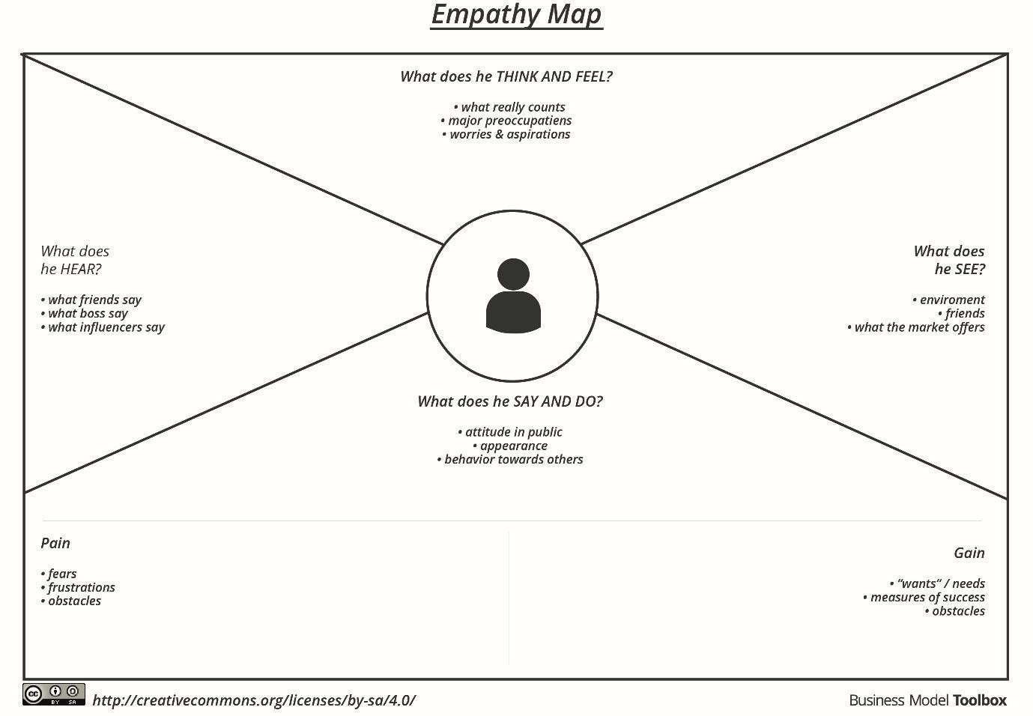

Reference: https://[www.mural.co/templates/empathy-map-canvas](http://www.mural.co/templates/empathy-map-canvas)

**Example: LearnHub**

